ASSIGNMENT 7.3
Task 1: Fixing Syntax Errors
Scenario
You are reviewing a Python program where a basic function definition contains a syntax error.

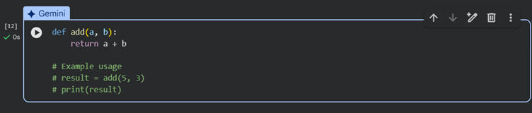
Task 2: Debugging Logic Errors in Loops
Scenario
You are debugging a loop that runs infinitely due to a logical mistake
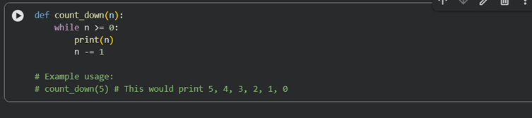
Task 3: Handling Runtime Errors (Division by Zero)
Scenario
A Python function crashes during execution due to a division by zero error

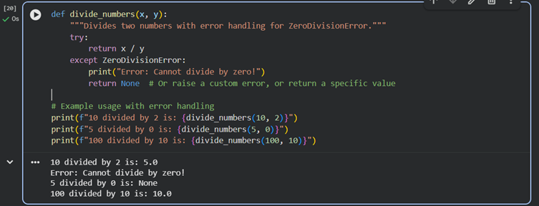
Task 4: Debugging Class Definition Errors
Scenario
You are given a faulty Python class where the constructor is incorrectly defined
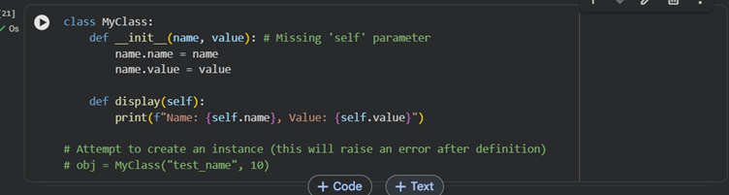
Task 5: Resolving Index Errors in Lists
Scenario
A program crashes when accessing an invalid index in a list
